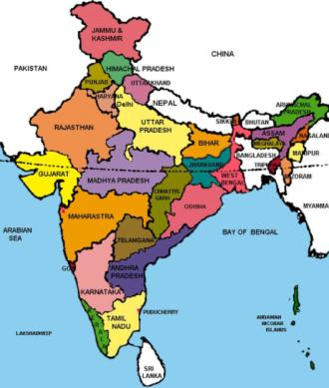
Haryana and Telangana
Haryana is located in the northern part of the country.
Haryana is also known as “The Home of Gods “,
whereas Telangana is a state in India situated on the
south-central stretch of the Indian peninsula on the
high Deccan Plateau. It is the eleventh-largest state
and the twelfth-most populated state in India.
regional language of Haryana is Haryanvi and Telangana
is Tamil.

Food of Haryana:
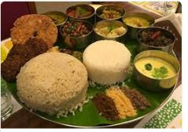
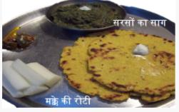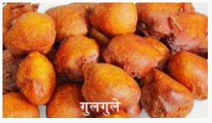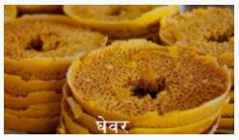
Food of Telangana:

Dresses of Haryana:
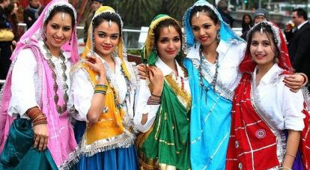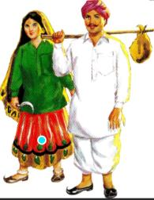
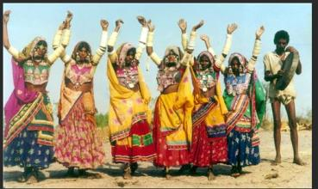
Dresses of Telangana:

Folk dance of Haryana:
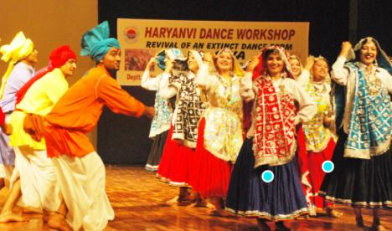
Folk dance of Telangana:
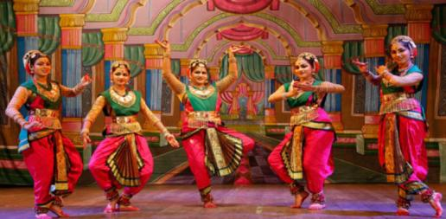
THANK YOU.

